Muhammad Arham
L1F23BSSE0372
Data.js File:
// data.js

const books = [
{
id: 101,
title: "Web Application Development",
author: "Ray Tomlinson",
isAvailable: true
},
{
id: 102,
title: "Operating System",
author: "Ray Khalid",
isAvailable: true
},
{
id: 103,
title: "Data Structure",
author: "Doctor Nouman",
isAvailable: false
},
{
id: 104,
title: "Database System",
author: "Mr. Sha Hussain",
isAvailable: false
}
];

module.exports = { books };

Index.JS FILE:
// index.js

const express = require("express");
const app = express();
app.set("json spaces", 2);
const port = 3000;

const { books } = require("./data.js");

// Start server
app.listen(port, () => {
console.log("Server is open now on port", port);
});

// 1 List of All Books
app.get("/api/books", (req, res) => {
res.json(books);

});

// 2 List of Available Books
app.get("/api/books/available", (req, res) => {
const availableBooks = books.filter(book => book.isAvailable === true);
res.json(availableBooks);
});

// 3 List of Issued (Unavailable) Books
app.get("/api/books/issued", (req, res) => {
const issuedBooks = books.filter(book => book.isAvailable === false);
res.json(issuedBooks);
});

// 4 Find Books by Specific Author (Query Parameter)
app.get("/api/books/search", (req, res) => {
const authorName = "Ray Khalid".toLowerCase();

const search = authorName.toLowerCase();
const matchedBooks = books.filter(book => book.author.toLowerCase().includes(search));

if (matchedBooks.length > 0) {
res.json(matchedBooks);
} else {
res.status(404).json({ message: "No books found for this author." });
}
});

OUTPUT:
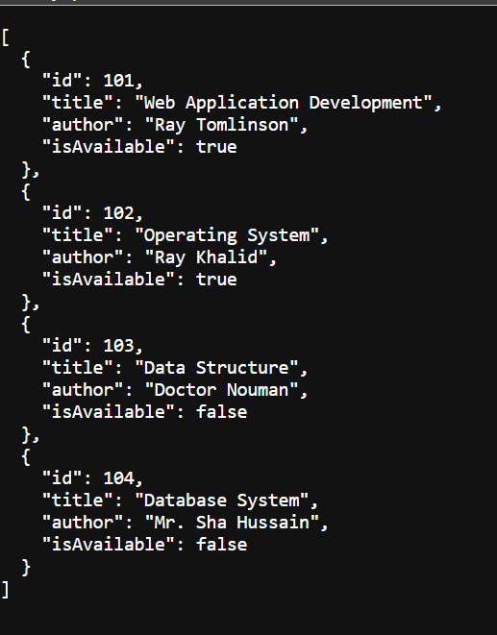
Retrieve All Books:
List Of Available Books
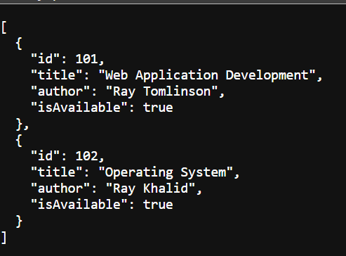
List Of Issued Books
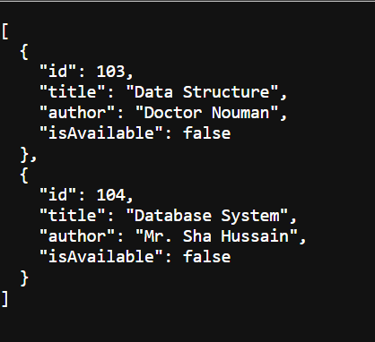

Find Book By Author Name:
